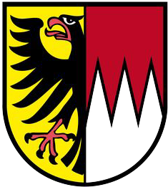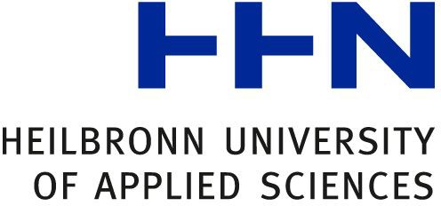

Diploma Supplement
This Diploma Supplement model was developed by the European Commission, Council of Europe and UNESCO/CEPES. The purpose of the supplement is to provide sufficient independent data to improve the international ‘transparency’ and fair academic and professional recognition of qualifications (diplomas, degrees, certificates etc.). It is designed to provide a description of the nature, level, context, content and status of the studies that were pursued and successfully completed by the individual named on the original qualification to which this supplement is appended. It should be free from any value judgements, equivalence statements or suggestions about recognition. Information in all eight sections should be provided. Where information is not provided, an explanation should give the reason why.

1. INFORMATION IDENTIFYING THE HOLDER OF THE QUALIFICATION
1.1 Family name(s) / 1.2 First name(s)
{LASTN}, {FIRSTN}
1.3 Date of birth (mm/dd/yyyy)
{BDATE}
1.4 Student identification number or code
not of public interest

2. INFORMATION IDENTIFYING THE QUALIFICATION
2.1 Name of qualification and title conferred (in original language)
Master of Science (M. Sc.)
2.2 Main field(s) of study for the qualification
Computer Science
Development of software, management of software-intensive projects
2.3 Name and status of awarding institution (in original language)
Hochschule Heilbronn – Technik, Wirtschaft, Informatik
University of Applied Sciences / State Institution of Higher Education

2.4 Name and status of institution administering studies (in original language)
see 2.3
2.5 Language(s) of instruction/examination
English

3. INFORMATION ON THE LEVEL AND DURATION OF THE QUALIFICATION
3.1 Level of the qualification
Postgraduate degree (Master of Science) which qualifies its holder for advanced technical or management positions in course-related professions.
3.2 Official duration of programme in credits and/or years
1.5 years, 90 ECTS
3.3 Access requirement(s)
- A Bachelor’s degree or Diploma in computer science or a closely-related field awarded for a programme of 210 ECTS. Alternatively, Diploma or Bachelor´s degree in a different field, and proof of formal training or practical experience with computer science for at least three years. Final grade corresponding to the German grade of 2,5 or better.
- An attested high level or proficiency in English (e.g. an IELTS score of 6.0). Native speakers of English are exempt from this requirement, as are those candidates who have previously completed a degree programme which is predominantly delivered in English.

4. INFORMATION ON THE PROGRAMME COMPLETED AND THE RESULTS OBTAINED
4.1 Mode of study
Full-time
4.2 Programme learning outcomes
The programme is aimed at students with a background in software engineering, software education or software project work who are open-minded and curious. The subject of the master program in Software Engineering is the design and evaluation of systems, methods, and tools for information processing. This master

program supplements, expands, and deepens the knowledge of a relevant bachelor's degree in such a way that graduates can independently analyze and solve problems in software engineering as well as master the scientific methods of the subject and independently expand and improve them.
This master program enables graduates to make tactical and strategic decisions in the selection and application of information processing systems and tools and to participate in research and methodological development in the field of software engineering. Furthermore, it enables graduates to lead and manage software engineering projects. To give the students the opportunity to develop content-related focal points, three professional profiles are offered, of which the student can choose one.

Programme details, individual credits gained and grades/marks obtained
See Certificate ("Masterzeugnis") for the final results (written and oral) and the subject of the thesis.

Grading system
Program achievements can be assessed using grades. The following grading system is to be used for the assessment:
(1) = very good; “Sehr Gut” = an excellent performance;
(2) = good; “Gut” = a performance significantly above the average requirements;
(3) = satisfactory; “Befriedigend” = a performance that meets the average requirements;
(4) = sufficient; “Ausreichend”= a performance that meets the requirements despite its deficiencies;
(5) = non-sufficient/fail; “Nicht ausreichend” = a performance that no longer meets the requirements because of significant deficiencies.

Overall classification of the qualification (in original language)
{GRADETEXT}
Based on the weighted average of the grades achieved in the examination fields. See appendix for grade distribution table.

INFORMATION ON THE FUNCTION OF THE QUALIFICATION
  - Access to further study
Qualifies for admission to Ph.D. or Doctoral Studies.

5.2 Access to a regulated profession
The Master Degree in this discipline entitles its incumbent to hold the legally protected professional title of “Master of Science” and to fill professional or management positions in the field of Computer Science for which this degree was awarded. Moreover, it gives them access to top-level careers within the German Civil Service.

6. ADDITIONAL INFORMATION
6.1 Additional Information
---

6.2 Further information sources
On the institution: https://www.hs-heilbronn.de/ On the program: http://www.hs-heilbronn.de/sem/
For national information sources cf. Sec. 8.8

7. CERTIFICATION
This Diploma Supplement refers to the following original documents:
- Document on the award to the academic degree (Urkunde über die Verleihung des Abschlussgrades) {GRANT}
- Certificate (“Zeugnis”) issued on {GRANT}

Certification Date: {DELIVERDATE}
{CHAIRPERSON}
Chairperson Examination Committee

(Official Stamp/Seal)

8. NATIONAL HIGHER EDUCATION SYSTEM
The information on the national higher education system on the following pages provides a context for the above qualification and for the type of higher education institution that awarded it.

- INFORMATION ON THE GERMAN HIGHER EDUCATION SYSTEM1  - Types of Institutions and Institutional Status  Higher education (HE) studies in Germany are offered at three types of Higher Education Institutions (HEI).2  - Universitäten (Universities) including various specialized institutions, offer the whole range of academic disciplines. In the German tradition, universities focus in particular on basic research so that advanced stages of study have mainly theoretical orientation and research-oriented components.  - Fachhochschulen (FH)/Hochschulen für Angewandte Wissenschaften (HAW) (Universities of Applied Sciences, UAS) concentrate their study programmes in engineering and other technical disciplines, business-related studies, social work, and design areas. The common mission of applied research and development implies an application-oriented focus of studies, which includes integrated and supervised work assignments in industry, enterprises or other relevant institutions.  - Kunst- und Musikhochschulen (Universities of Art/Music) offer studies for artistic careers in fine arts, performing arts and music; in such fields as directing, production, writing in theatre, film, and other media; and in a variety of design areas, architecture, media and communication.  Higher Education Institutions are either state or state-recognized institutions. In their operations, including the organization of studies and the designation and award of degrees, they are both subject to higher education legislation. | - Types of Programmes and Degrees Awarded  Studies in all three types of institutions have traditionally been offered in integrated "long" (one-tier) programmes leading to Diplom- or Magister Artium degrees or completed by a Staatsprüfung (State Examination).  Within the framework of the Bologna-Process one-tier study programmes are successively being replaced by a two-tier study system. Since 1998, two-tier degrees (Bachelor and Master) have been introduced in almost all study programmes. This change is designed to provide enlarged variety and flexibility to students in planning and pursuing educational objectives, they also enhance international compatibility of studies.  The German Qualifications Framework for Higher Education Qualifications (HQR)3 describes the qualification levels as well as the resulting qualifications and competences of the graduates. The three levels of the HQR correspond to the levels 6, 7 and 8 of the German Qualifications Framework for Lifelong Learning4 and the European Qualifications Framework for Lifelong Learning5.  For details cf. Sec. 8.4.1, 8.4.2, and 8.4.3 respectively. Table 1 provides a synoptic summary.  - Approval/Accreditation of Programmes and Degrees  To ensure quality and comparability of qualifications, the organization of studies and general degree requirements have to conform to principles and regulations established by the Standing Conference of the Ministers of Education and Cultural Affairs of the Länder in the Federal Republic of Germany (KMK)6. In 1999, a system of accreditation for Bachelor’s and Master’s programmes has become operational. All new programmes have to be accredited under this scheme; after a successful accreditation they receive the seal of the Accreditation Council.7

Table 1: Institutions, Programmes and Degrees in German Higher Education
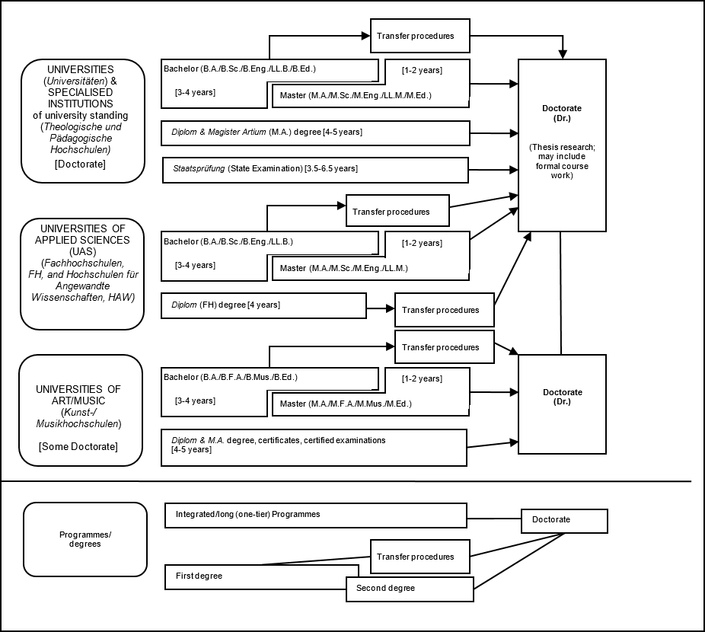

Organization and Structure of Studies
The following programmes apply to all three types of institutions. Bachelor’s and Master’s study courses may be studied consecutively, at various higher education institutions, at different types of higher education institutions and with phases of professional work between the first and the second qualification. The organization of the study programmes makes use of modular components and of the European Credit Transfer and Accumulation System (ECTS) with 30 credits corresponding to one semester.

Bachelor
Bachelor’s degree study programmes lay the academic foundations, provide methodological skills and include skills related to the professional field. The Bachelor degree is awarded after 3 to 4 years. The Bachelor’s degree programme includes a thesis requirement. Study courses leading to the Bachelor’s degree must be accredited according to the Interstate study accreditation treaty.8
First degree programmes (Bachelor) lead to Bachelor of Arts (B.A.), Bachelor of Science (B.Sc.), Bachelor of Engineering (B.Eng.), Bachelor of Laws (LL.B.), Bachelor of Fine Arts (B.F.A.), Bachelor of Music (B.Mus.) or Bachelor of Education (B.Ed.).
The Bachelor’s degree corresponds to level 6 of the German Qualifications Framework/ European Qualifications Framework.

Master
Master is the second degree after another 1 to 2 years. Master’s programmes may be differentiated by the profile types “practice-oriented” and “research-oriented”. Higher Education Institutions define the profile.
The Master’s degree programme includes a thesis requirement. Study programmes leading to the Master degree must be accredited according to the Interstate study accreditation treaty.9
Second degree programmes (Master) lead to Master of Arts (M.A.), Master of Science (M.Sc.), Master of Engineering (M.Eng.), Master of Laws (L.L.M.), Master of Fine Arts (M.F.A.), Master of Music (M.Mus.) or Master of Education (M.Ed.). Master’s programmes which are designed for continuing education may carry other designations (e.g. MBA).
The Master’s degree corresponds to level 7 of the German Qualifications Framework/ European Qualifications Framework.

Integrated "Long" Programmes (One-Tier):
Diplom degrees, Magister Artium, Staatsprüfung
An integrated study programme is either mono-disciplinary (Diplom degrees, most programmes completed by a Staatsprüfung) or comprises a combination of either two major or one major and two minor fields (Magister Artium). The first stage (1.5 to 2 years) focuses on broad orientations and foundations of the field(s) of study. An Intermediate Examination (Diplom- Vorprüfung for Diplom degrees; Zwischenprüfung or credit requirements for the Magister Artium) is prerequisite to enter the second stage of advanced studies and specializations. Degree requirements include submission of a thesis (up to 6 months duration) and comprehensive final written and oral examinations. Similar regulations apply to studies leading to a Staatsprüfung. The level of qualification is equivalent to the Master’s level.
      - Integrated studies at Universitäten (U) last 4 to 5 years (Diplom degree, Magister Artium) or 3 to 6.5 years (Staatsprüfung). The Diplom degree is awarded in engineering disciplines, the natural sciences as well as economics and business. In the humanities, the corresponding degree is usually the Magister Artium (M.A.). In the social sciences, the practice varies as a matter of institutional traditions. Studies preparing for the legal, medical and pharmaceutical professions are completed by a Staatsprüfung. This applies also to studies preparing for teaching professions of some Länder.
The three qualifications (Diplom, Magister Artium and Staatsprüfung) are academically equivalent and correspond to level 7 of the German Qualifications Framework/ European Qualifications Framework.
They qualify to apply for admission to doctoral studies. Further prerequisites for admission may be defined by the Higher Education Institution, cf. Sec. 8.5.
      - Integrated studies at Fachhochschulen (FH)/Hochschulen für Angewandte Wissenschaften (HAW) (Universities of Applied Sciences, UAS) last 4 years and lead to a Diplom (FH) degree which corresponds to level 6 of the German Qualifications Framework/ European Qualifications Framework.
Qualified graduates of FH/HAW/UAS may apply for admission to doctoral studies at doctorate-granting institutions, cf. Sec. 8.5.
      - Studies at Kunst- and Musikhochschulen (Universities of Art/Music etc.) are more diverse in their organization, depending on the field and individual objectives. In addition to Diplom/Magister degrees, the integrated study programme awards include Certificates and certified examinations for specialized areas and professional purposes.

Doctorate
Universities as well as specialised institutions of university standing, some of the FH/HAW/UAS and some Universities of Art/Music are doctorate- granting institutions. Formal prerequisite for admission to doctoral work is a qualified Master’s degree (UAS and U), a Magister degree, a Diplom, a Staatsprüfung, or a foreign equivalent. Comparable degrees from universities of art and music can in exceptional cases (study programmes such as music theory, musicology, pedagogy of arts and music, media studies) also formally qualify for doctoral work. Particularly qualified holders of a Bachelor’s degree or a Diplom (FH) degree may also be admitted to doctoral studies without acquisition of a further degree by means of a procedure to determine their aptitude. The universities respectively the doctorate-granting institutions regulate entry to a doctorate as well as the structure of the procedure to determine aptitude. Admission further requires the acceptance of the Dissertation research project by a professor as a supervisor.
The doctoral degree corresponds to level 8 of the German Qualifications Framework/ European Qualifications Framework.

Grading Scheme
The grading scheme in Germany usually comprises five levels (with numerical equivalents; intermediate grades may be given): "Sehr Gut" (1) = Very Good; "Gut" (2) = Good; "Befriedigend" (3) = Satisfactory; "Ausreichend" (4) = Sufficient; "Nicht ausreichend" (5) = Non-Sufficient/Fail. The minimum passing grade is "Ausreichend" (4). Verbal designations of grades may vary in some cases and for doctoral degrees.
In addition, grade distribution tables as described in the ECTS Users’ Guide are used to indicate the relative distribution of grades within a reference group.

Access to Higher Education
The General Higher Education Entrance Qualification (Allgemeine Hochschulreife, Abitur) after 12 to 13 years of schooling allows for admission to all higher educational studies. Specialised variants (Fachgebundene Hochschulreife) allow for admission at Fachhochschulen (FH)/Hochschulen für Angewandte Wissenschaften (HAW) (UAS), universities and equivalent higher education institutions, but only in particular disciplines. Access to study programmes at Fachhochschulen (FH)/Hochschulen für Angewandte Wissenschaften (HAW) (UAS) is also possible with a Fachhochschulreife, which can usually be acquired after 12 years of schooling. Admission to study programmes at Universities of Art/Music and comparable study programmes at other higher education institutions as well as admission to a study programme in sports may be based on other or additional evidence demonstrating individual aptitude.
Applicants with a qualification in vocational education and training but without a school-based higher education entrance qualification are entitled to a general higher education entrance qualification and thus to access to all study programmes, provided they have obtained advanced further training certificates in particular state-regulated vocational fields (e.g. Meister/Meisterin im Handwerk, Industriemeister/in, Fachwirt/in (IHK), Betriebswirt/in (IHK) und (HWK), staatlich gebrüfte/r Techniker/in, staatlich geprüfte/r Betriebswirt/in, staatlich geprüfte/r Gestalter/in, staatlich geprüfte/r Erzieher/in). Vocationally qualified applicants can obtain a Fachgebundene Hochschulreife after completing a state-regulated vocational education of at least two years’ duration plus professional practice of normally at least three years’ duration, after having successfully passed an aptitude test at a higher education institution or other state institution; the aptitude test may be replaced by successfully completed trial studies of at least one year’s duration.10
Higher Education Institutions may in certain cases apply additional admission procedures.

National Sources of Information
- Kultusministerkonferenz (KMK) [Standing Conference of the Ministers of Education and Cultural Affairs of the Länder in the Federal Republic of Germany]; Graurheindorfer Str. 157, D-53117 Bonn; Phone: +49[0]228/501- 0; www.kmk.org; E-Mail: hochschulen@kmk.org
- Central Office for Foreign Education (ZAB) as German NARIC; www.kmk.org; E-Mail: zab@kmk.org
- German information office of the Länder in the EURYDICE Network, providing the national dossier on the education system; www.kmk.org; E- Mail: Eurydice@kmk.org
- Hochschulrektorenkonferenz (HRK) [German Rectors’ Conference]; Leipziger Platz 11, D-10117 Berlin, Phone: +49 30 206292-11; www.hrk.de; E-Mail: post@hrk.de
- "Higher Education Compass" of the German Rectors’ Conference features comprehensive information on institutions, programmes of study, etc. (www.higher-education-compass.de)

- The information covers only aspects directly relevant to purposes of the Diploma Supplement.
- Berufsakademien are not considered as Higher Education Institutions, they only exist in some of the Länder. They offer educational programmes in close cooperation with private companies. Students receive a formal degree and carry out an apprenticeship at the company. Some Berufsakademien offer Bachelor courses which are recognised as an academic degree if they are accredited by the Accreditation Council.
- German Qualifications Framework for Higher Education Degrees. (Resolution of the Standing Conference of the Ministers of Education and Cultural Affairs of the
Länder in the Federal Republic of Germany of 16 February 2017).
- German Qualifications Framework for Lifelong Learning (DQR). Joint resolution of the Standing Conference of the Ministers of Education and Cultural Affairs of the Länder in the Federal Republic of Germany, the German Federal Ministry of Education and Research, the German Conference of Economics Ministers and the German Federal Ministry of Economics and Technology (Resolution of the Standing Conference of the Ministers of Education and Cultural Affairs of the Länder in the Federal Republic of Germany of 15 November 2012). More information at www.dqr.de
- Recommendation of the European Parliament and the European Council on the establishment of a European Qualifications Framework for Lifelong Learning of 23 April 2008 (2008/C 111/01 – European Qualifications Framework for Lifelong Learning – EQF).
- Specimen decree pursuant to Article 4, paragraphs 1 – 4 of the interstate study accreditation treaty (Resolution of the Standing Conference of the Ministers of Education and Cultural Affairs of the Länder in the Federal Republic of Germany of 7 December 2017).
- Interstate Treaty on the organization of a joint accreditation system to ensure the quality of teaching and learning at German higher education institutions (Interstate study accreditation treaty) (Decision of the Standing Conference of the Ministers of Education and Cultural Affairs of the Länder in the Federal Republic of Germany of 8 December 2016), Enacted on 1 January 2018.
- See note No. 7.
- See note No. 7.
- Access to higher education for applicants with a vocational qualification, but without a school-based higher education entrance qualification (Resolution of the Standing Conference of the Ministers of Education and Cultural Affairs of the Länder in the Federal Republic of Germany of 6 March 2009)

Appendix: Grade Distribution Table:

No grading table is available because there are fewer than 30 graduates in your degree program.

